**Separation Challenge**

**NAME: CLASS:**

Now that you are a scientist who has trained in separating techniques, it is time to test your skills! Your challenge is to separate a mixture containing several substances and collect each pure substance into its own container.

**GROUPS**

You will work in pairs to complete this challenge. The partner that you will need to work with will be randomly chosen.

|  |
| --- |
| **My partner is** |

**MIXTURE**

The mixture you will need to separate will be randomly selected. Write the substances that your mixture contains below:

|  |
| --- |
| **My mixture contains** |

**PLANNING**

1. Think about the properties of each pure substance in your mixture. This may help you decide on a way to separate the substances. Write what you know about the properties of each substance in the table below:

|  |  |  |  |
| --- | --- | --- | --- |
| SUBSTANCE | SOLUBLE IN WATER? | ATTRACTED TO MAGNET? | FLOATS/SINKS IN WATER? |
|  |  |  |  |
|  |  |  |  |
|  |  |  |  |
|  |  |  |  |

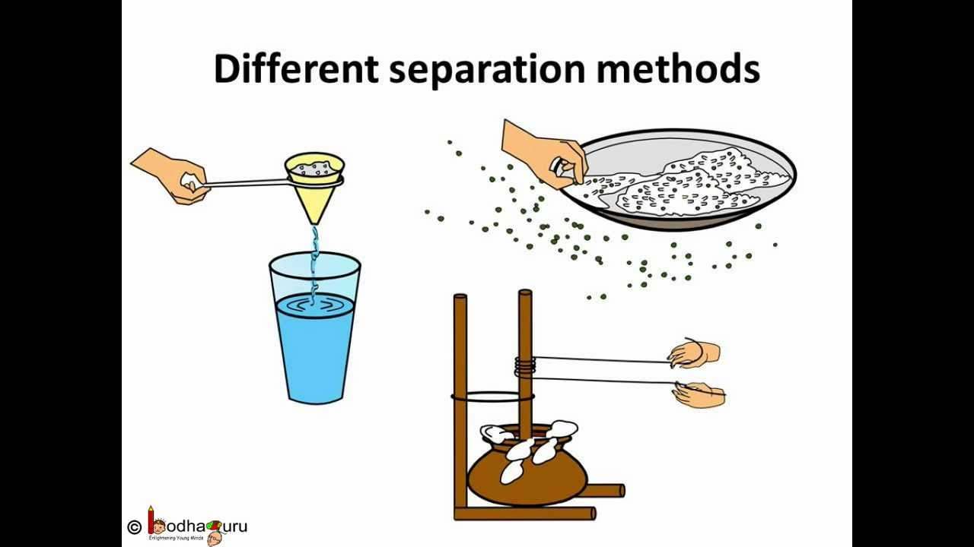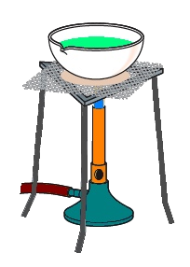

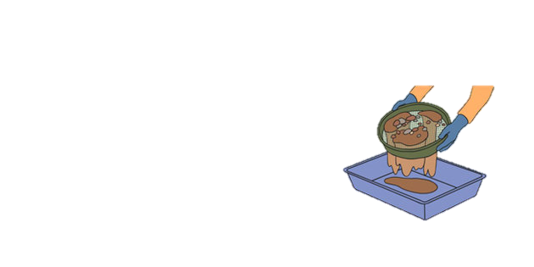

1. Discuss with your partner some possible ways to separate the four substances out of your mixture. Draw a flow chart showing the steps you will take and the order you will conduct them in. Once you are happy with your plan, have your flow chart checked by your teacher.

Include:

* 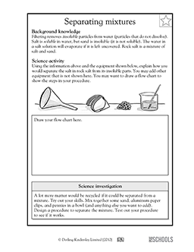Diagrams of the equipment you will use
* Labels with the name of each piece of equipment
* A description of what you expect to happen during each step

***FLOW CHART***

1. Once your teacher has checked your plan, write a list of ALL the equipment you will need to complete your separation challenge. ***NOTE: You may only use equipment available in the laboratory (HINT - think about what we have used in previous lessons!!)***

***EQUIPMENT LIST***

* Mixture containing , , and
* .
* .
* .
* .
* .
* .
* .
* .
* 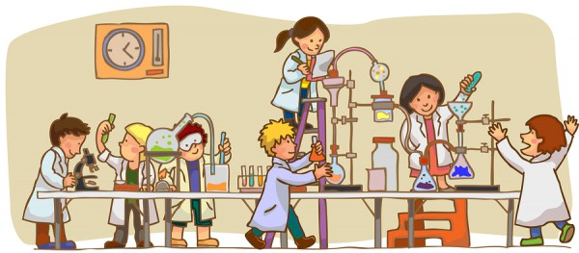.

***Hand in your booklet to your teacher and get ready to conduct your scientific separation!***

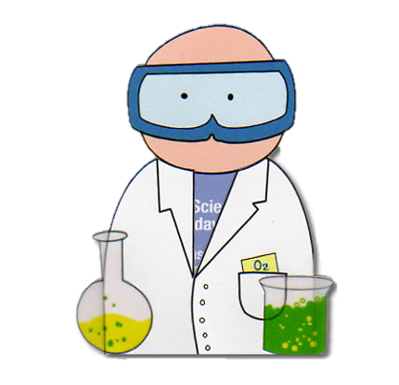**CONDUCTING**

While you are using your plan to separate your mixture, make some observations about what happened at each step. You can use a combination of diagrams and words to record what happened.

***STEP #1***

***STEP #2***

***STEP #3***

***STEP #4***

***STEP #5***

**REFLECTION**

1. How well did your plan work? Grade the success of your plan on a scale of 1-5, where 1 means the experiment did not work well and 5 means the experiment was a great success.

**3**

**4**

**2**

**5**

**1**

**Great success!**

**Did not work well**

1. If your success was lower than 5 on the scale, how would you change your plan to improve the results next time?

.

1. Did you manage to separate the four substances successfully? Write some reasons why/why not (what factors caused your separation to be successful/unsuccessful).

1. This challenge required you to work with a partner. How well did you work as a team? Write some examples of how you worked well/did not work well.



***SEPARATION CHALLENGE – Marking Guide Name:***

|  |  |  |  |  |
| --- | --- | --- | --- | --- |
| ***Marking Criteria*** | ***3 marks*** | ***2 marks*** | ***1 mark*** | ***0 marks*** |
| ***Planning of separation*** | ***Appropriate techniques chosen, correctly named and in sensible order*** | ***Appropriate techniques chosen but incorrectly named or inappropriate order*** | ***Inappropriate techniques chosen*** | ***Not attempted*** |
| ***Equipment chosen*** | ***Appropriate equipment to complete the separation techniques chosen*** | ***Some essential equipment missing from plan*** | ***Most essential equipment missing from plan*** | ***Not attempted*** |
| ***Conducting separation techniques*** | ***All components completely separated; all steps clearly recorded in detail*** | ***Components mostly separated; most steps recorded in detail*** | ***Not all components separated; steps recorded with limited detail*** | ***Components not separated; steps not recorded*** |
| ***Safety hazards considered and minimised*** |  |  | ***Appropriate use of personal protective equipment and sensible work practice*** | ***Inappropriate safety considerations and conduct in the laboratory*** |
| ***Reflection*** | ***Well thought out and detailed comments*** | ***Complete comments*** | ***Incomplete comments*** | ***Not attempted*** |